**Project Name:** Real Fake Image Classification

**Github Link:** https://github.com/projectsforstudents2022/Real_Fake_Image_Classification.git

**Why was this project created?**

Deep learning algorithms have become so powerful as computing power has increased that it has become much easier to create indistinguishable human-synthesized videos, dubbed fake images. It’s easy to imagine scenarios in which these realistic fake images are used to commit political pranks, staged terrorist assaults, revenge pornography, and blackmail.

**What problem is it solving?**

While visual effects have been used to display convincing modifications of digital pictures for decades, current breakthroughs in deep learning have resulted in a huge rise in the realism of false material and the simplicity with which it may be made. These ostensibly AI-generated media. It is an easy process to create using artificially intelligent techniques,

but detecting these fake images is a huge difficulty. So our project is to detect real vs fake image.

**Entire explanation of project**

* **PROPOSED APPROACH**

We study a variety of research papers before determining whether the problem description is feasible. The next phase is to collect and analyze data sets. we discovered that balanced algorithm training is the greatest technique to reduce bias and variation in the algorithm while still achieving excellent accuracy. We opted to use the Flask framework in conjunction with the Python programming language. Flask was chosen because it supports the Graphic Processing Unit well and is easily customizable. The final model was trained on a huge number of data sets using Google Cloud Platform. Our model was tested on a large variety of real-time datasets, including the Facebook picture data collection.

The trained model’s accuracy is assessed using the Confusion Matrix technique. The solution’s conclusion is trained fake image detection models that will assist users in determining if a picture is fake or real. The user will upload the image and submit the video for processing using a web-based application. The model will pre-process the image and determine if it is deep fake or genuine.

Algorithm for creating next word prediction model :

**Step 1:** Import Libraries & Load Dataset

**Step 2:** Image Preprocessing

**Step 3:** : Hyper-Parameter Tuning

**Step 4:** Build Neural Network

**Step 5:** Train Model

**Step 6:** Testing & Visualization

* **DATA FLOW DIAGRAM**

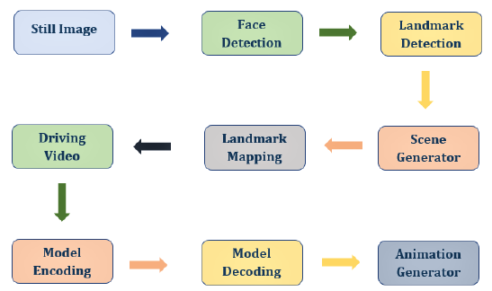

* **RESULT**

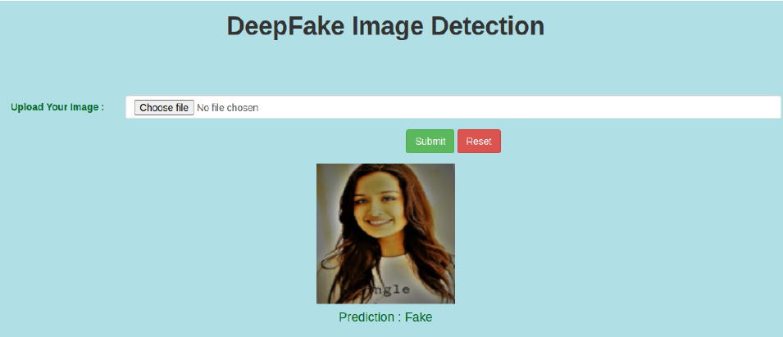

* **CONCLUSION**

We introduced a neural network-based method for classifying images as fake or real, as well as the model’s confidence level. Our technology is capable of accurately anticipating the outcome from image processing. We used a pre-trained ResNext CNN model to extract frame level features and an LSTM for temporal sequence processing to identify changes between the t and t-1 frames to develop the model. Our algorithm can analyze the image and anticipate the outcome.